Sample Promotional Graphics

Use the provided graphics to promote the Maintain, Don’t Gain! Holiday Challenge to your employees, coworkers, friends, and family on your social media platforms.

- Select an image from our graphic library for Facebook, Instagram, and Twitter. Use the blank space to add your organization’s logo.
- Or, get creative and create your own graphics and add the Holiday Challenge logo. If you do not have an image editing platform, try creating a free account through a platform like Canva.

Facebook Graphics 1200 x 630 (1:9:1 ratio)

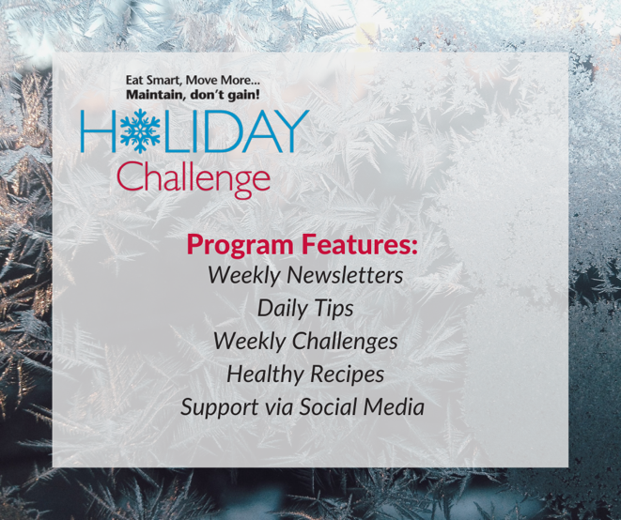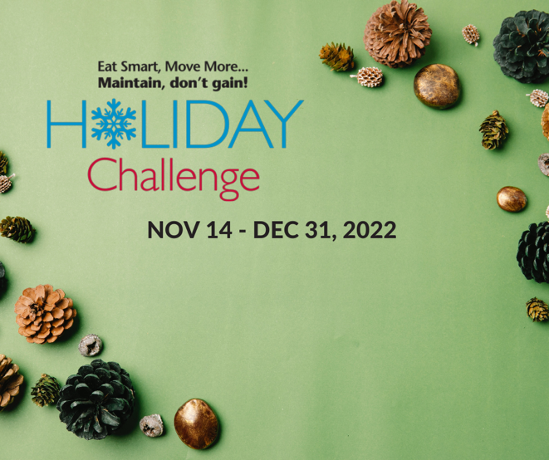
(The bottom two options have space to add a logo)

Instagram Graphics 1080 x 1080

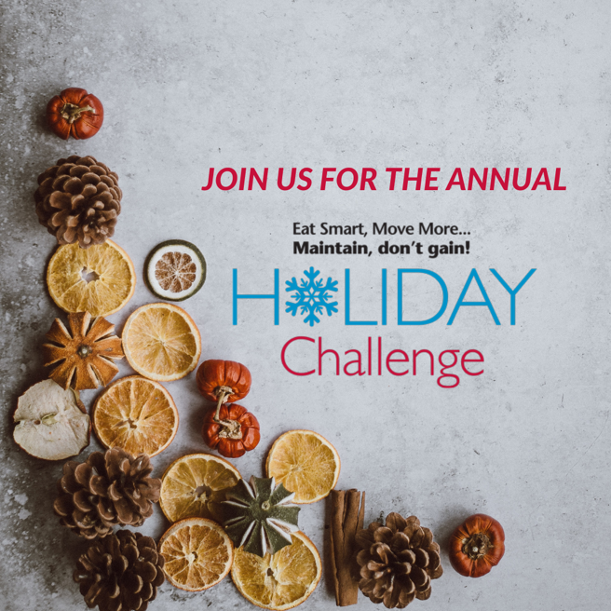

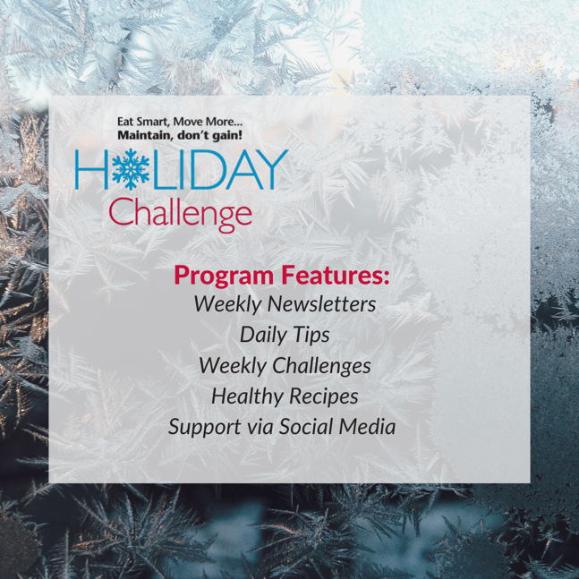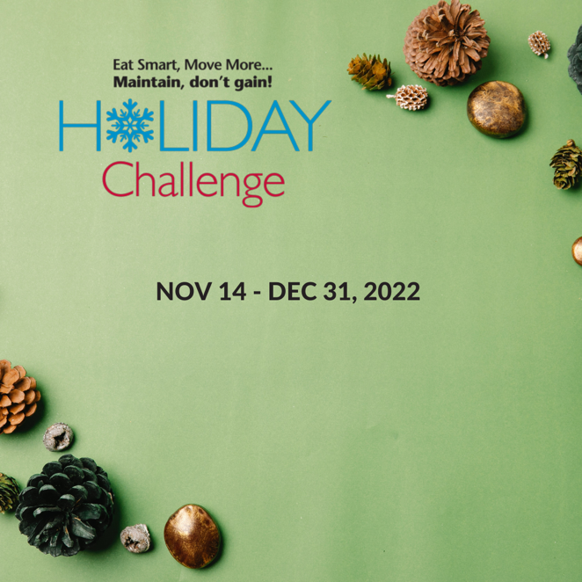

(The bottom two options have space to add a logo)

Twitter Graphics 1200 x 675 (16:9 ratio)

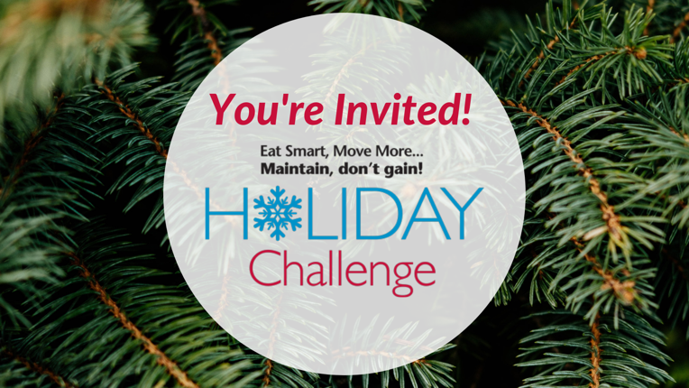

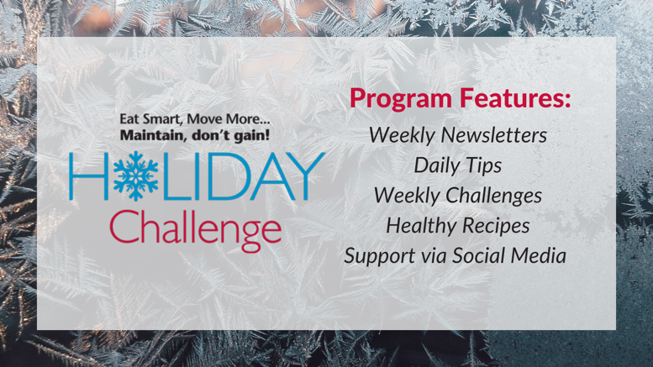

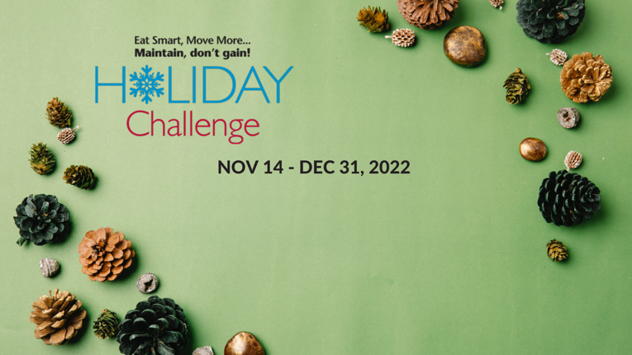
(The bottom two options have space to add a logo)

