Fitmas Tree Challenge:
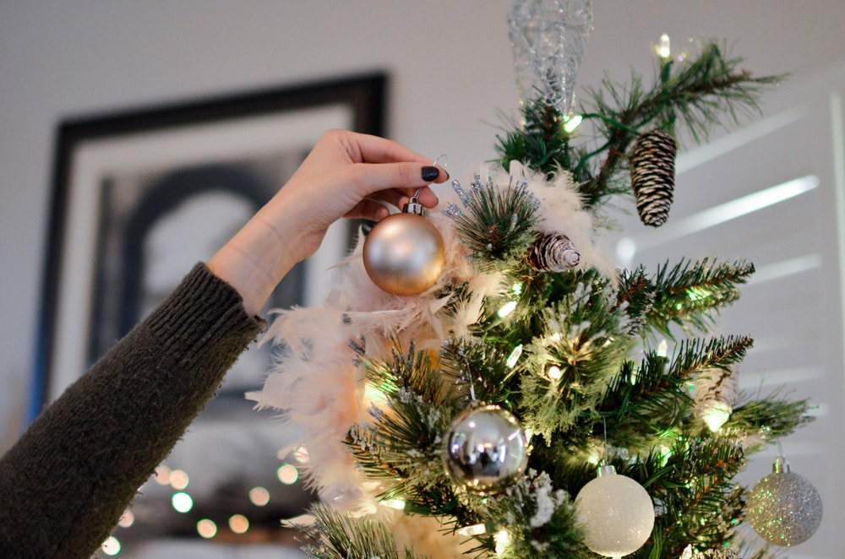

Even though Thanksgiving is around the corner, individuals may decorate their home for the holidays before the day full of turkey. Often, people may have their friends and family over to celebrate Thanksgiving and want their house nicely decorated beforehand. Other times, people may wait until the week before Christmas to decorate. Whether you are a proactive decorator or a procrastinator, there are a few options to make your home a winter wonderland while also fitting in a quick workout that requires no equipment. My family and I enjoy the Fitmas Tree Challenge every year! This challenge can be modified to how you decorate your house (color, specific ornaments, etc.) in addition to the type of exercise you prefer. Don’t cheat; continue to decorate your house as beautifully as you normally do. Below is the type of exercises you can do including a video link on how to do each one as well.

- For every gold and/or silver ornament hung:
  - 2 Push-ups
- For every red ornament hung:
  - 10 Jumping Jacks
- For every ornament/decoration made by hand:
  - 7 Squat Jumps
- For every ornament that has a picture of your family:
  - 10 Triceps Dips
- For every snowflake item/ornament hung:
  - 6 High Knees
- Tree topper:
  - 15 Burpees
- For every stocking hung:
  - 20 Mountain Climbers
- For every wreath hung (on windows, doors, and walls):
  - 20 Knee Ups (10 on each side)
- For every piece of garland hung (on stairwell, fireplace, front porch, etc.):
  - 20 Static Lunges (10 on each side)
- For every seasonal candle put out:
  - 20 Flutter Kicks
- For every Elf on the Shelf character you own:
  - 20 Sumo Squats
- For every seasonal center piece (coffee table, dining room table, etc.):
  - 20 Oblique Crunches (10 on each side)
- For every piece of mistletoe hung:
  - 30 Second Wall Sit
- For every hot chocolate consumed when decorating:
  - 30 Second Plank

Other Body Weight Exercise Options:
- Abdominal Bicycle
- Arm Circles
- Butt Kicks
- Calf Raises
- Crunches
- Leg Hold (or Hollow Body Hold)
- Leg Raises
- Reverse Crunch
- Russian Twist
- Shoulder Tap Push Up
- Side Lunges
- Side Plank
- Sit Ups
- Squats
- Squat Pulse
- Sumo Squat Jumps
- Walking Lunges

