Sample Blog Post or Newsletter Article

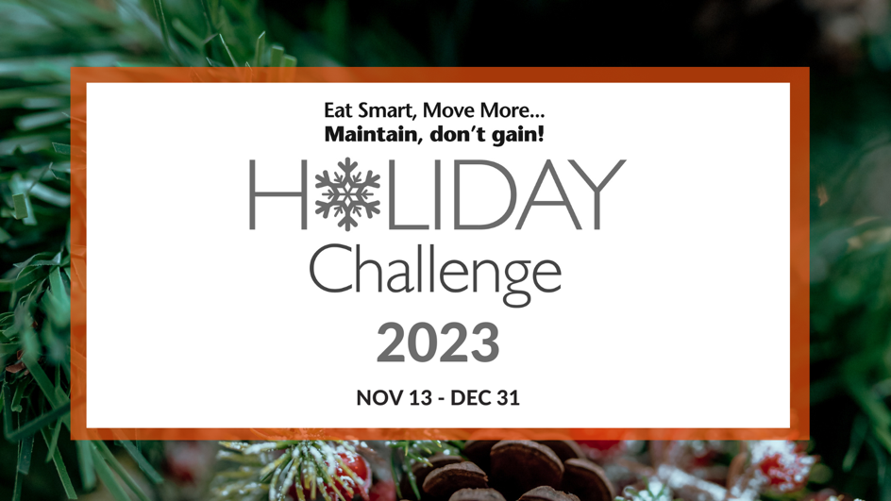

You are invited to join the 17th annual Eat Smart, Move More, Maintain, don’t gain! Holiday Challenge. Rather than focusing on trying to lose weight, this FREE seven-week challenge provides you with strategies and resources to maintain your weight throughout the holiday season. Any adult over 18 years of age across the United States with a valid email address can join the Holiday Challenge.

The Holiday Challenge will begin November 13th and run through December 31st. Registration does not close and you may sign-up at any time. Participants can engage as much or as little as they would like to, as all resources are sent to their email and available online. Register now by visiting: https://esmmweighless.com/sign/.
Holiday Challenge Features:
- Weekly Newsletters
- Daily Tips
- Healthy Holiday Recipes
- Weekly Challenges
- Tools
- Private Facebook Community
Last year's Holiday Challenge:
In 2022, more than 40,900 people from all 50 states and all 100 North Carolina counties and 32 additional countries took part in the Holiday Challenge. At the end of the Holiday Challenge, 92% maintained or lost weight and 98% are likely to participate in a future Holiday Challenge. For additional results, and to see how your state ranked in participation, click here: Holiday Challenge Results.
For Holiday Challenge updates, resources, and support:
- Facebook - @esmmweighless
- Twitter - @esmmweighless
- Pinterest - @esmmweighless
- Instagram - @esmmweighless
For any questions regarding the Holiday Challenge, check out the FAQ page or email us at holidaychallenge@esmmweighless.com.
The Holiday Challenge is provided by Eat Smart, Move More, Weigh Less, a 15-week online weight management program delivered by a live Registered Dietitian Nutritionist, and Eat Smart, Move More, Prevent Diabetes, a 12-month online diabetes prevention program recognized by the CDC. Both programs are developed and managed by NC State University and the NC Division of Public Health.

