Note: This Press Release is intended to be a guide. We encourage you to add your own quotes, elaborate on your individual or organizational activities and customize this as you see fit. Please send to Casey Collins, Diabetes Prevention Program Coordinator @cecolli2@ncsu.edu for approval before publishing.

YOUR ORGANIZATION’S LOGO HERE 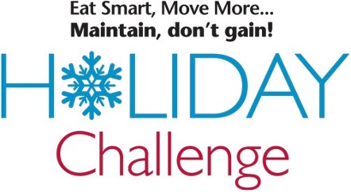

For Immediate Release
Media Contact: PR contact’s name
(xxx) xxx-xxxx,
email@company.com

[Organization Name] Promotes The 17th Annual Maintain, Don’t Gain! Holiday Challenge.

Month X, 2023 – [Organization Name] is promoting the 17th annual Eat Smart, Move More, Maintain, don’t gain! Holiday Challenge to help our [employees, community, audience, etc.] focus on healthy eating and physical activity this holiday season! The challenge begins on November 13th, 2023.

Many Americans gain between 1 and 5 pounds each holiday season. While it might not sound like much, most people never manage to lose those extra pounds. Rather than focusing on trying to lose weight, this FREE seven-week challenge provides you with strategies and resources to help maintain your weight throughout the holiday season.
Any adult over 18 years of age across the United States with a valid email address can join the Holiday Challenge. Registration does not close and you may sign-up at any time. The Holiday Challenge features weekly newsletters, daily tips, weekly challenges, tools, and a private Facebook community to foster social support and encouragement throughout the 7-week program. Participants can engage as much or as little as they would like to, as all resources are sent to their email and available online.
In 2022, more than 40,900 people from all 50 states and all 100 North Carolina counties and 32 additional countries took part in the Holiday Challenge. At the end of the Holiday Challenge, 92% maintained or lost weight and 98% are likely to participate in a future Holiday Challenge. For additional results, and to see how your state ranked in participation, click here: Holiday Challenge Results. Help us make 2023 the biggest year yet!
Sign up to get healthy recipes, daily tips, exercise ideas and more by visiting: https://esmmweighless.com/sign/

About [Organization Name]
Insert your standard boilerplate message here.

About the Eat Smart, Move More Maintain, don’t gain! Holiday Challenge
The Holiday Challenge is provided by Eat Smart, Move More, Weigh Less, a 15-week online weight management program delivered by a live Registered Dietitian Nutritionist, and Eat Smart, Move More, Prevent Diabetes, a 12-month online diabetes prevention program recognized by the CDC. Both programs are developed and managed by NC State University and the NC Division of Public Health.
Follow us on Facebook @esmmweighless; on Twitter @esmmweighless; on Pinterest @esmmweighless; and on Instagram @esmmweighless.

